Computer Networks

Lab 08

Name: Ahmed Kasteer

Section: 5C

Roll Number: 20F-0336

Task 1

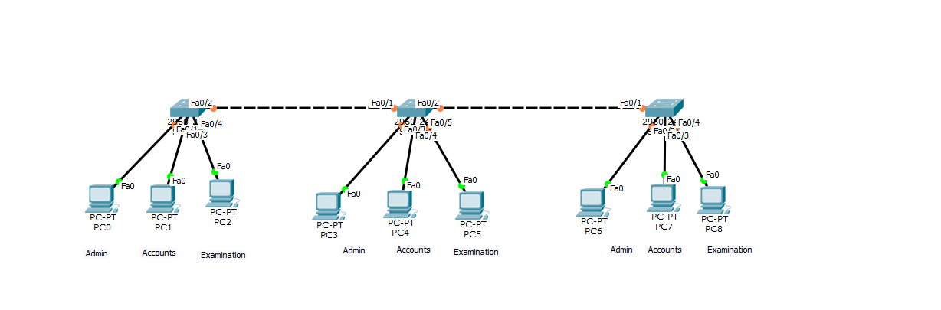

Task 2

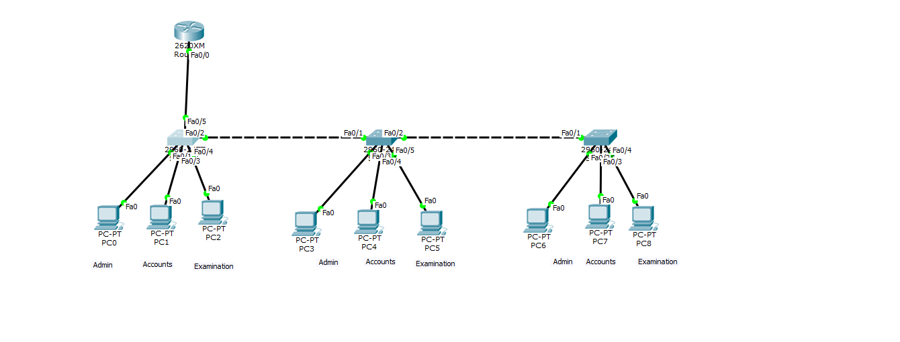

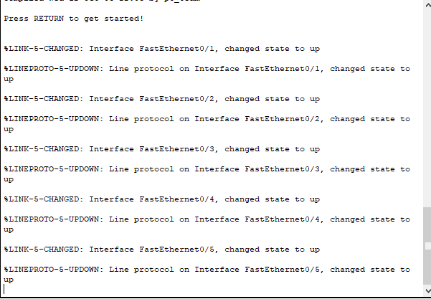

Task 3

